LAB (2) 18CSC303J (Database Management Systems)

RA1811029010016

Mohit Verma

TABLE supplier016

**Create table**

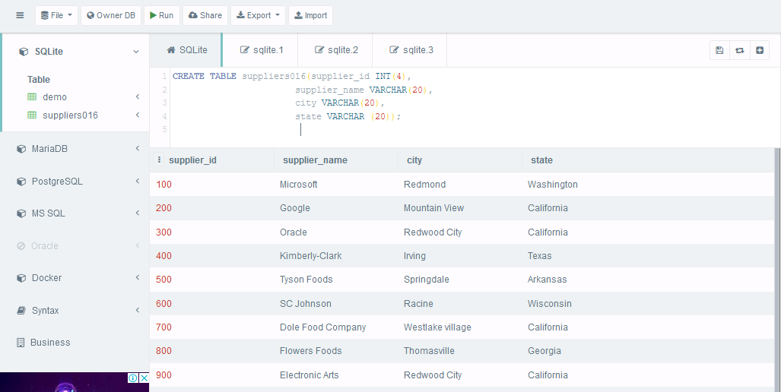

**Describe table**

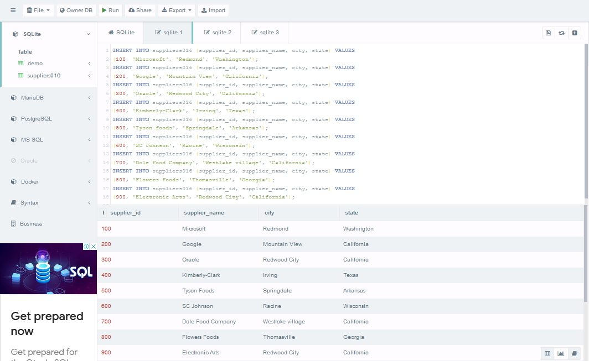

**Alter the field**

**Due to profit loss the Tyson foods has been handled to Nike beverages in Arkansas**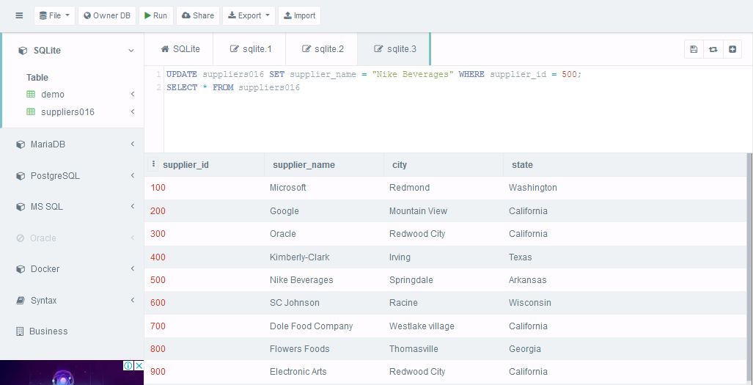

**Due to recent trends in mobile application google is replaced with apple with id 150 and in Cupertino**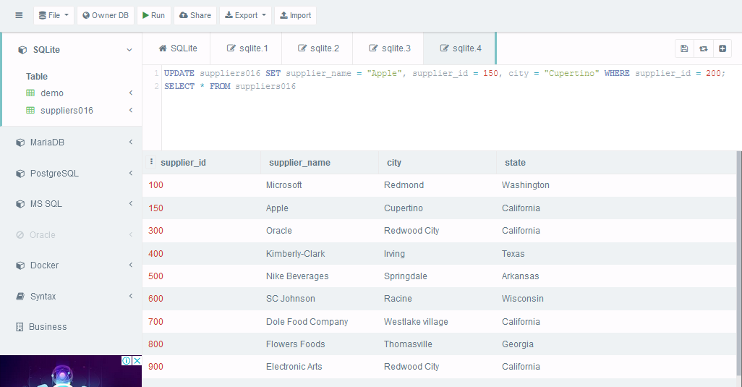

**To widely publicize the flowers foods have created new branch in Redwood City, California of id 1000**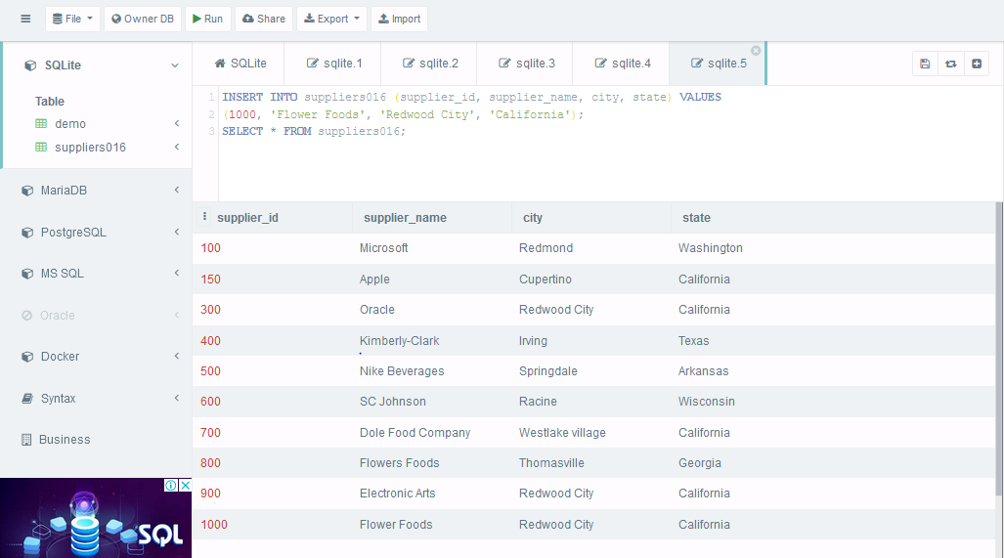

**Due to lock down all the suppliers are stop at Redwood City, California**

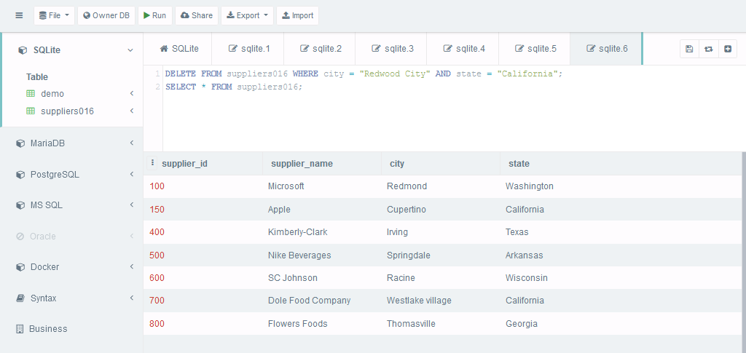

**Due to low profit Kimberly-Clark is removed from the market**

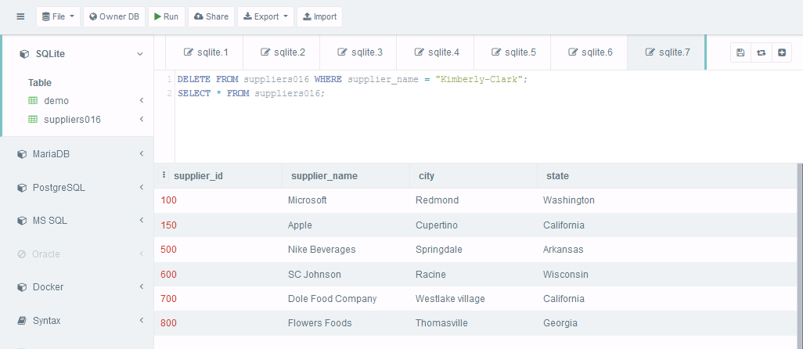

1. Write the various datatypes that are support by SQL

Ans. Numeric data types such as int, tinyint, bigint, float, real etc.

Date and Time data types such as Date, Time, Datetime etc.

Character and String data types such as char, varchar, text etc.

Unicode character string data types, for example nchar, nvarchar, ntext etc.

Binary data types such as binary, varbinary etc.

Miscellaneous data types – clob, blob, xml, cursor, table etc.

1. Is it possible to insert only few values in the table?

Ans. Yes, for this, we have to specify the column names in the SQL INSERT INTO statement.

1. Enumerate the possible constraints applicable to the field/column_name

NOT NULL

UNIQUE

PRIMARY KEY

FOREIGN KEY

CHECK

DEFAULT

1. Whether constraints can be enforced to the attributes once the table/relation that is created already.

Ans. Yes, A foreign key (FK) is a column or combination of columns that is used to establish and enforce a link between the data in two tables to control the data that can be stored in the foreign key table.